Soil Properties
Soil consists of a mass of solids particles separated by spaces or voids. The voids of a soil are usually a mixture of air and water (soil is partially saturated). In certain circumstances the voids may be completely filled with water or air only. If only air is present the soil is dry and if only water is present the soil saturated. The Figure1 shows a cross-section through a granular soil.
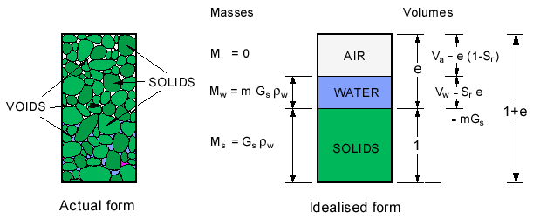
Figure 1 Cross-section through granular soil
.In order to study the properties we will adopt the idealised form of the diagram shown in Figure 1. The soil mass has a total volume V, containing a volume of solid particles V_{s} and a volume of voids V_{v}. In most cases the void volume exists of a mixture of water (V_{w}) and air (V_{a}).
Figure 2 shows the three cases in diagrammatic form (a) soil & air (b) soil & water and (c) soil with water & air
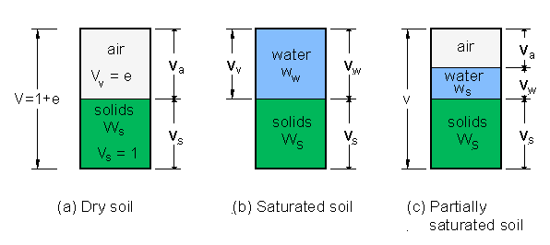
Figure 2 Water and air contents in a soil
Void ratio (e)
The volume of voids, Vv, is obviously equal to V - V_{s}.
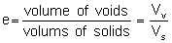
(V_{v} (volume of voids = volume not occupied by solids.)
For ease of calculating we will assume that all solids are compressed together and their volume considered equal to a unit volume as shown in Figure 1 and Figure 2.
Porosity (n)
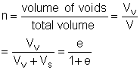
usually V_{v} = V_{a} + V_{w}

Moisture content (m)
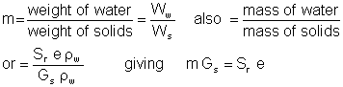
The specific gravity of solids is G_{s} and the density of water is _{w}
Mass of solids, M_{s} = G_{s} _{w}
Mass of water, M_{w} = S_{r} e _{w}
The quantities in the above formula are used in the opposite equation.

Degree of saturation (S_{r})
When both air and water are present the soil is said to be partially saturated. The degree of saturation is simply
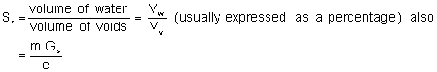

Air-void ratio
Percentage air voids
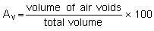 Also 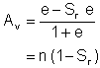
The ratio of the volume of air to the total volume of soil multiplied by 100 is known as the percentage air voids.

Density () and unit weight ()
We can express the amount of material in a given volume , V, in two ways:
1. the amount of mass, M, in the volume, or
2. the amount of weight, W, in the volume.
The more common way is to use the amount of mass instead of the amount of weight. Using the weight necessitates in a conversion as shown below:
The weight is:
weight = mass × gravitational acceleration
[Gravitational acceleration = 9.81 m/s² (for ease use 10 m/s²)]
The unit for the force or weight is the newton (N) (1 N = 1kg × 1 m/s²)
the weight of 1 kg on earth = 10 N
(Density of water at 4°C, _{w} = 1000 kg/m³ = 1 Mg/m³)

Specific gravity (G_{s})
The specific gravity of a material is the ratio of the weight or the mass of a volume of the material to the weight or mass of an equal volume of water.
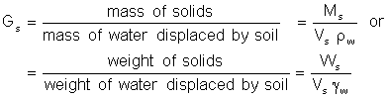
Bulk density()
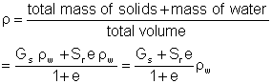
Dry density(_{d})
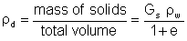

Example calculation
A soil sample has a weight of 0.7 kg and the volume was found to be
3.5 × 10⁻⁴ m³ After drying out the weight was reduced to 0.6 kg. The particle specific gravity test gave 2.6.
Determine the following:
(a) Moisture content
(d) Void ratio
(b) Dry density
(e) Porosity
(c) Bulk density
(f) Degree of saturation

(a) Moisture content
Mass of water is 0.7 kg - 0.6 kg = 0.1 kg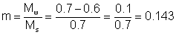
or in percentage 14.3%
(b) Dry density
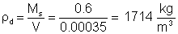
(c) Bulk density
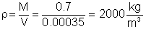
To calculate the void ratio we must first calculate the volume of solids. Then we can find the volume of voids by subtracting the volume of solids from the total volume.
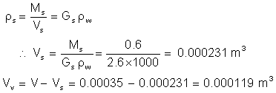
(d) Void ratio  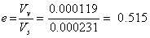  (e) Porosity  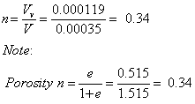 | (f) Degree of saturation  